‘Angry Birds in Space’ Infographic Rubric
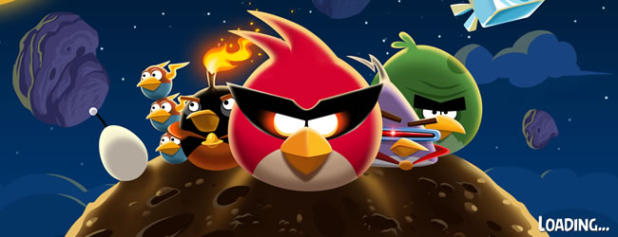  Criteria (Checklist) | High (Epic) | Sound (Cool) | Basic (Aight)
CONTENT  (Information, vocabulary, purpose) | Topic is focused, with a clear, engaging infographic. All data is relevant and conveys meaningful information to the viewer. | Topic is focused, and most of the data is relevant. The viewer can understand the purpose for the infographic. | Little focus of the topic, with no clear purpose. Data is missing or irrelevant.
EVIDENCE OF LEARNING  (Investigating, Communicating, Collaborating) | Strong evidence of author’s understanding, original, critical thinking, going beyond existing information while incorporating an explicit reflective connection of self, community or humanity to the topic. | Adequate evidence of author’s critical thinking with an implied reflective connection of self, community or humanity to the topic. | Evidence minimal or missing of author’s understanding and critical thinking – mostly repeating existing information (summary report) with no personal connections made.
LAYOUT  (Design, fonts, colours, graphics) | Layout shows clear organisation and creates an easy-to-follow and easy to read infographic. Excellent use of graphics and colour scheme to help guide the viewer. | Mostly clear and organised, but may be confusing in spots. Some use of graphics and colour schemes to help guide the viewer. | Confusing layout and/or data. Little use of colour schemes or graphics to guide the viewer.
REFERENCES  Examples @ http://bit.ly/refinfo | Sources thoroughly documented and credited. | Sources mostly documented and credited. | Documentation and credits for sources missing.

